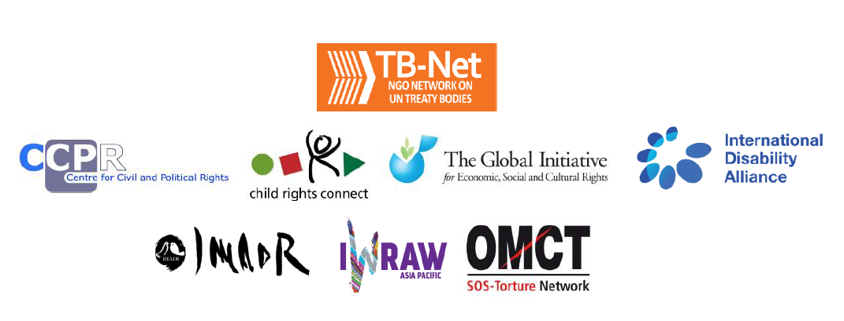

**TB-Net Statement on the 30th meeting of Chairpersons of the Human Rights Treaty Bodies**

This is a joint statement on behalf of seven organizations[1], which form the NGO Network on UN Treaty Bodies (TB-Net). Created in February 2017, TB-Net is an informal group of international NGOs and networks who work closely with the UN treaty bodies and have specialised expertise on their procedures and substantive work.

**Our mission**

Our mission is to support and enhance the effectiveness of the UN treaty bodies so that they can better contribute to the realisation of the human rights of all persons.

**Our vision**

We believe that treaty bodies to be effective need to:

* Have quality, independent and diverse membership;
* Develop clear, coherent and context-relevant recommendations;
* Have transparent, accessible, inclusive and rights-holder-oriented processes and procedures;
* Create spaces for meaningful and safe engagement of civil society and human rights defenders and consider their views;
* Be visible and vocal within the broader UN human rights system and at the country level.

We believe there is a need to move towards thinking of the treaty bodies as a system, rather than individual silos and this includes the way NGOs work with the system. Working together as a group, we have a holistic and in depth view of the treaty body system, enabling us to identify trends, good practices and comprehensive approaches, common challenges and avenues for shared learning and collaboration across treaty bodies. Further, together we can improve, outreach to, and accessibility for, rights-holders and civil society at the national level, across the system.

In support of our vision and mission, we as TB-Net are pursuing two main projects including co-leading and facilitating two key meetings: one on the follow-up procedures and one on treaty body membership. In addition, TB-Net has been monitoring the provision of Webcasting of treaty body public meetings, and we are concerned by the lack of information on funding for its continuation and by shortcomings in its current provision.

**1. Follow-up procedures**

Together with the OHCHR, the Geneva Academy, the Open Society Justice Initiative and Judgment Watch, TB-Net organised a meeting in October 2017 attended by members of all treaty bodies, and discussed the measures treaty bodies take to monitor the States parties’ implementation of recommendations. It affirmed that the follow-up procedures in the treaty body system are crucial for the effective implementation of the recommendations as they allow treaty bodies to maintain a dialogue with States during the period between the State review and the next periodic report and to support them with the compliance of their obligations under the respective treaties. It also stressed the need for treaty bodies to streamline their procedures.

**Recommendations**

* The follow-up procedure should be adopted by all the treaty bodies as a crucial element of the reporting cycle;
* Treaty bodies should in their concluding observations invite States to inform them about their implementation plans for all recommendations, including those identified for follow-up;

Treaty bodies should work towards an aligned, coherent and transparent follow-up and assessment procedure, based on existing good practices, and adopt joint guidelines as recommended in the report of the expert meeting on follow-up to treaty body recommendations (HRI/MC/2018/CPR.2).

**2. Quality, Independent and Diverse Treaty Body Membership**

In order to ensure quality, independent and diverse treaty bodies, TB-Net focuses on the promotion of transparent and participatory nominations and elections processes. Last November, we organised an event on promoting quality, independence and diversity in treaty body membership[2] and we will do so again in a side event to this Chairperson’s meeting to start discussions about the role of treaty bodies in relation to elections. We believe that multi-stakeholder cooperation between States, civil society, the OHCHR as well as the treaty bodies in nomination and election processes are the only way to ensure a pool of highly qualified independent and diverse candidates.

**Recommendations**

* Treaty bodies should call on States to organise open, participatory, transparent and structured national nomination processes to ensure public scrutiny of the candidates prior to their nomination;
* Treaty bodies should encourage States to ensure in both nominations and elections that the candidates are persons of high moral standing, have recognised competence and experience in the human rights field covered by the relevant treaty, and are independent as well as to give consideration to equitable geographic distribution and balanced gender representation, and diverse backgrounds and experiences;

Before every election, treaty bodies should assist States in identifying the most appropriate candidate by recalling the key requirements for treaty body membership i.e. availability to dedicate time, sensitiveness to cultural differences, etc., and by encouraging States to take into account the current composition of the concerned treaty body and its outgoing members as well as the current and potential gaps in expertise, regional and gender balance.

**3. Official Webcast of Treaty Bodies public meetings**

TB-Net appreciates the advancements by treaty bodies in ensuring that UN Web TV provides official webcast of public meetings, in English and in relevant languages for the country (whether in another UN language with interpretation provided by UNOG, or a non-UN national language when States provide for interpretation- e.g. CEDAW Committee on Republic of Korea). This is key to allow civil society and the right-holders of each State to access the substantive discussions on their rights.

However, TB-Net is extremely concerned that funds would only be available for webcast till June 2018, with no available information indicating continuation. In terms of current -and future- operation, we believe that procedures for the provision of alternative UN languages and of national language must be improved to allow for timely dissemination of related information and prevent any inconvenience, gap of transmission or confusion of the users of the webcast during the public sessions.

**Recommendations**

* Treaty bodies should seek to request and ensure that funding is immediately available to continue with the provision of official webcast by UN Web TV, in a foreseeable and sustainable manner.
* Treaty bodies, involving their Secretariats, should develop and formalise clear protocols to definitively institutionalise the practice of providing, when relevant, webcast in alternative UN languages and in non-UN national languages when States provide for interpretation. In this last case, prior communication with States (to check if they will provide interpretation in their national language) and UN departments involved (for inclusion of the national language in the options of languages in UN Web TV) is key to ensure in advance notice to the potential audience at the national level (e.g. in informative notes by the treaty bodies) and proper provision of webcast.

We hope you will consider our recommendations and we look forward to continued engagement on these issues.

Thank you,

The NGO Network on UN Treaty Bodies (TB-Net)

1. Centre for Civil and Political Rights (CCPR-Centre), Child Rights Connect, the Global Initiative for Economic, Social and Cultural Rights (GIESCR), the International Disability Alliance (IDA), the International Movement Against All Forms of Discrimination and Racism (IMADR), International Women’s Rights Action Watch Asia Pacific (IWRAW-Asia Pacific) and the World Organisation Against Torture (OMCT)
2. “Promoting Quality, Independence and Diversity in Treaty Body Membership: the Importance of Transparent and Participatory Nominations and Election Processes”, <https://www.facebook.com/notes/tb-net/event-report-promoting-quality-independence-and-diversity-in-treaty-body-members/2017859365128158/>